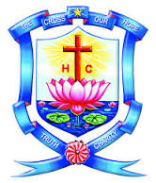
HOLY CROSS COLLEGE
(Autonomous)
Affiliated to Bharathidasan University
Nationally Accredited (4th Cycle) with A++ Grade (CGPA3.75/4) by NAAC
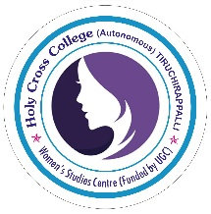
College with Potential for Excellence Tiruchirappalli – 620002, Tamil Nadu, India.
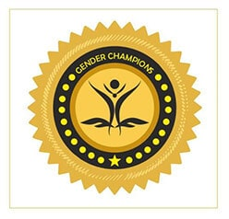

WOMEN’S STUDIES CENTRE
(FUNDED BY UGC)

&
GENDER CHAMPION CLUB

We cordially invite you for…

Programme
On
Status of Women in India at Present

Date: 14/12/2023 Time: 12.50 p.m. to 2. p.m Venue: MCB Block Room No: 115
RESOURCE PERSON PRESIDED BY
Rev.(Sr.) Dr.IsabellaRajakumari
Principal
Holy Cross College (Autonomous)
Tiruchirappalli -620 002.

Dr.S.Shanthi Getzie Ranjini Devi
Associate Professor
Department of Economics
Bishop Heber College (Autonomous)
Tiruchirappalli – 620 017

More Info

Organising Committee

Dr.P.Prisheela, WSC Co-ordinator, HCC
Dr.S.Elavarasi, Assistant Professor of Zoology, HCC
Ms.B.Steffi Sagaya Mary Assistant Professor of English, HCC
Dr.A.Saranya Assistant Professor of Mathematics, HCC

All are Invited

